**Accommodate**

**Amphibious Buildings**

*Overview:*

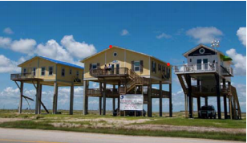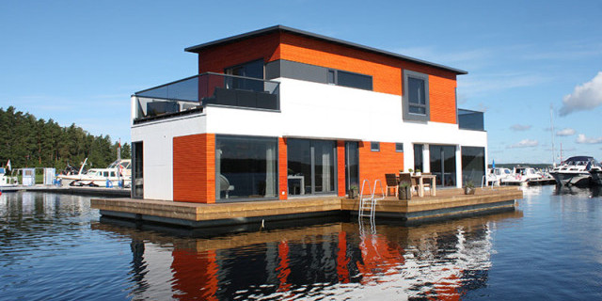

Figure 1. (left). Elevated house in Galveston Texas 1

Figure 2. (right). A floating house 2

Amphibious architecture is an adaptation strategy where structures are designed to adapt to flooding. In this way, a structure is less susceptible to inundation. Some amphibious buildings are built on elevated foundations. Other buildings are constructed on foundations that under normal circumstances rest firmly on a solid surface. However, during periods of flooding, the building floats. Amphibious buildings with the capacity to float are supported by a buoyancy system that allows the base of a building to move as the water level changes. Therefore, amphibious architecture is ideally suited to flood-prone regions with natural cycles of flooding.  3

***Types of amphibious buildings:***

* **Dry roof structures** prevent water from entering a building during a flood. These structures incorporate internal or external flood protection barriers 7
* **Wet roof structures** allow floodwaters to flow into and remain in a building during a flood and flow out of the building when the floodwater begins to subside. Wet roof structures are constructed with materials that can withstand flood damage. Hence, wet roof structures are designed to mimic natural landscapes such as floodplains 7
* **Permanent static elevations** are structures that are permanently elevated as an adaptation measure to flooding. They are usually located in areas where flooding occurs regularly 6
* **Buoyant foundations** allow a building to sit on a regular foundation during dry weather but float during a flood. Buoyancy foundations consist of three basic elements, buoyancy blocks that allow the building to float, vertical guideposts that control the movement of the structure up and down, and a subframe that holds the platform and building together 4, 5

Benefits:

* Increases the value of real estate because of flood adaptation design
* Adaptable to variation in flood water levels 5
* Reduces the level of damage due to flooding
* Amenable to soil subsistence and changes in sea level rise 6

Challenges

* Increases the cost for access to services such as sewage disposal, water supply, power, and gas, when compared to non-amphibious buildings 5
* Static elevated buildings are more vulnerable to the wind because elevation increases the effects of high wind speed on the building.
* Insurance companies may be reluctant to provide adequate coverage due to the increased risk of flood damage.
* Municipalities may be hesitant to issue permission for development approval

*FLOAT House (New Orleans LA, USA):*

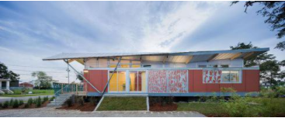

Figure 3. Float house prototype 3

The Float House is a prototype for housing that adapts to coastal flooding. It is used in coastal areas that are susceptible to flooding. The design features an adaptable frame that acts as a raft. Guided steel masts allow the house to float up to as high as 12 feet.1 Not only does the float boat adapt to floods it also produces its own energy.2 The float boat project is a great example of sea-level rise adaptation through research and design.

*Floating Houses (BC, Canada):*

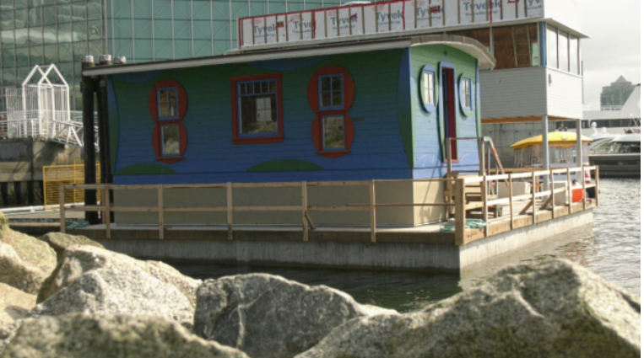

Figure 3. Floating cabin; False Creek British Columbia 4

Examples of floating houses or houseboats can be found in British Columbia along False Creek on Granville Island. These float houses are a landmark. Each house exhibits its own unique character. In the south of Richmond along the Fraser River, floating homes can also be found near Ladner and Queensborough. These little neighborhoods are examples of resiliency through water-based urbanism and embracing water as a culture. It should be noted, however, that because of planning regulations, it might be difficult to implement floating houses as an adaptation strategy at larger scales.

*References:*

1. “FLOAT House.” *Morphopedia*, https://www.morphosis.com/architecture/126/.
2. Ibid
3. English, E., Klink, N., & Turner, S. (2016). Thriving with water: Developments in amphibious architecture in North America. In E3S Web of Conferences (Vol. 7, p. 13009). EDP Sciences. Retrieved from, <https://buoyantfoundation.org/wp-content/uploads/2017/04/FloodRisk_2016_ECEnglish_finalpaper.pdf>
4. English, E. (2009, November). Amphibious foundations and the buoyant foundation project: Innovative strategies for flood-resilient housing. In *International Conference on Urban Flood Management sponsored by UNESCO-IHP and COST Action C* (Vol. 22, pp. 25-27). <https://www.researchgate.net/figure/The-FLOAT-House-New-Orleans-Elevation-interior-guide-post-and-sleeve-detail_fig6_322675610>
5. Climate Adapt. Floating and amphibious housing (2015).<https://climate-adapt.eea.europa.eu/metadata/adaptation-options/floating-and-amphibious-housing/#ao_category>
6. Land8: Landscape Architects Network (2015). What is Amphibious Architecture and How Will it Help Cities Adapt to Climate Change? <https://land8.com/what-is-amphibious-architecture-and-how-will-it-help-cities-adapt-to-climate-change/>
7. Nilubon, P., Veerbeek, W., & Zevenbergen, C. (2016). Amphibious architecture and design: a catalyst of opportunistic adaptation? –case study Bangkok. Procedia-Social and Behavioral Sciences, 216, 470-480.

*Images:*

1. Figure 1. English et al. (2016). Thriving with water: Developments in amphibious architecture in north America. https://www.e3s-conferences.org/articles/e3sconf/pdf/2016/02/e3sconf_flood2016_13009.pdf
2. Figure 2. Brears. R. (n.d). A Floating House to Resist the Floods of Climate Change

.https://youngwaterleaders.thewaternetwork.com/article-FfV/a-floating-house-to-resist-the-floods-of-climate-change-zY8sRnPTmd2aqpyJrvinig

1. Figure 3. Morphosis Team. (2009). FLOAT House. https://www.morphosis.com/architecture/126/.
2. Figure 4. Mangione, K. (2019). Figure 4. Noticed the blue cabin floating in False Creek? Here's what it is. https://bc.ctvnews.ca/noticed-the-blue-cabin-floating-in-false-creek-here-s-what-it-is-1.4565356

**Accommodate**

**Dry Floodproofing**

*Overview:*

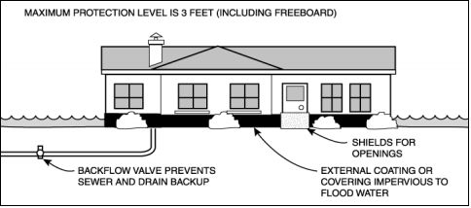

*Figure 1. Typical dry floodproofing building* 1

Dry floodproofing is a practice of utilizing waterproof membranes and other types of sealants to prevent floodwater from entering a building.1 It may also include the installation of watertight seals over windows and doors, diversion of water using berms and mounds, or the establishment of minimum setback regulations for building construction. 3, 5, 6, 7,11 The work required to dry flood-proof a structure could be determined through a risk assessment following local government requirements, guidelines, or policies.2, 3 Depending on the complexity of the requirements, dry floodproofing is usually a cost-effective retrofit. Dry floodproofing contributes to a reduction in potential flood damage by decreasing the probability of inundation to the interior of a building. Dry floodproofing is a useful alternative as a flood mitigation measure where the relocation or elevation of a building is not a plausible cost-effective or technically feasible alternative. 12

*Types of dry floodproofing measures:*

* **Continuous impermeable walls** include sealing the exterior walls of a building, utilizing waterproof membranes that are impermeable and that have the potential to strengthen the walls.
* **Flood resistant interior core areas** include important components and areas of a building that are made flood-resistant instead of dry proofing the entire footprint of the building.
* **Flood shields** are watertight structures that close any opening in a building’s exterior walls to prevent the entry of floodwater. 12
* **Internal drainage systems** are used to remove water that might seep into a building through fissures or other openings that comprise a flood protection system.

*Benefits:*

* Builds resilience by providing a secondary means of protection to dikes
* Improves flood protection when other measures are difficult to implement due to space constraints
* Less costly when compared to other methods of flood retrofitting
* The implementation does not require additional land space 11
* Can be used to bring non-residential structures into compliance with floodplain management regulations and codes 12

*Challenges*

* Will not minimize the impacts of high-velocity water flow and wave action on a building or structure 11
* May be difficult to apply to existing buildings and infrastructure
* May not always lead to an improvement in flood mitigation that aligns with existing floodplain management bylaws 11
* May fail, if flooding exceeds the level of flood protection intervention

*HafenCity (Hamburg, Germany):*

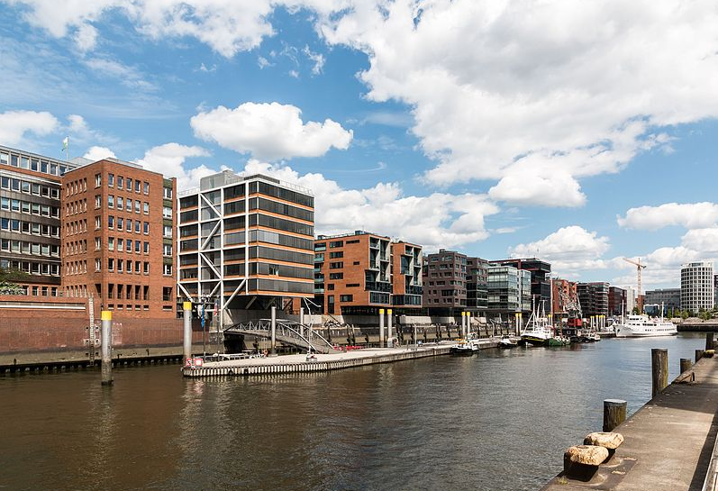

Figure 2. Hafen city *Hamburg, Germany* 2

HafenCity is an example of flood adaptation as an alternative to dike construction. The town wanted to retain the beautiful sightlines down to the water, therefore, a dike was not the best option.4 Instead, all new buildings were raised on plinths 8 to 9 meters above sea level.5 Plinths are artificial mounds that are built using compacted fill, and the interior function as spaces for underground parking. In addition to raising buildings, the roads and bridges of HafenCity are also built roughly eight (8) meters above sea level, therefore allowing the town to function seamlessly during a storm surge.6

*Farm Building FCL’s and Setbacks (BC, Canada):*

Dry floodproofing can also be in the form of defining flood construction levels (FCLs) and setbacks for new development. The government of British Columbia and the Ministry of Agriculture provide guidelines on the application of flood construction levels and floodplain setbacks.7 In British Columbia, FCLs are used to protect living spaces, electrical and mechanical services from the impact of floodwaters above.8 FCLs and setbacks are generally established in some locations but in some cases, they are defined by the elevation above a natural boundary such as a water source.9 Additionally, FCLs and setbacks can also be associated with land use, specifically for the location of farm buildings based on building type and size.10

*References:*

1. The Arlington Group Planning Architecture Inc., et al. *Sea Level Rise Adaptation Primer*. pp. 62. https://www2.gov.bc.ca/assets/gov/environment/climate-change/adaptation/resources/slr-primer.pdf
2. Ibid, 62.
3. FEMA. *Selecting Appropriate Mitigation Measures for Floodprone Structures*. 1 Mar. 2007, pp. 1. https://www.fema.gov/media-library-data/20130726-1608-20490-9182/fema_551_ch_07.pdf
4. HafenCity Hamburg GmbH. “Flood-Secure Bases Instead of Dikes: Safe from High Water in HafenCity.” *HafenCity*, https://www.hafencity.com/en/concepts/flood-secure-bases-instead-of-dikes-safe-from-high-water-in-hafencity.html.
5. Ibid.
6. Ibid.
7. *Flood Construction Levels and Setbacks for Farm Building Situations*. British Columbia Ministry of Agriculture, July 2008, pp. 2. https://www2.gov.bc.ca/assets/gov/farming-natural-resources-and-industry/agriculture-and-seafood/farm-management/structures-and-mechanization/823400-2_flood_const_levels_and_setbacks.pdf.
8. Ibid, 2.
9. Ibid, 3-4.
10. Ibid, 5.
11. FEMA (n.d) Chapter 7 dry floodproofing. Retrieve from <https://www.fema.gov/media-library-data/20130726-1608-20490-9182/fema_551_ch_07.pdf>
12. FEMA (n.d). Dry Floodproofing Measures. https://www.fema.gov/media-library-data/06dabddadc3887f91906172d863749ab/P-936_sec3_508.pdf

*Images:*

1. Figure 1. FEMA (n.d) Chapter 7 dry floodproofing. Retrieve from https://www.fema.gov/media-library-data/20130726-1608-20490-9182/fema_551_ch_07.pdf
2. Figure 2. Wikimedian Commonsé (2020). File:Hamburg, HafenCity, Bebauung am Sandtorkai -- 2016 -- 3036.jpg

**Accommodate**

**Emergency Planning and Preparedness**

*Overview:*

Emergency planning and preparedness is a coordinated process that involves assessing the likely impacts of a disaster event and coordinating a set of responses to reduce or prevent property damage. Planning approaches such as evacuation routes and plans, emergency management plans, tsunami response plans can be implemented before a disaster to reduce the damage to property, infrastructure, economy, and transportation.1 Preparing for coastal hazards allows local governments to declare a local emergency in the face of a storm surge.2 The effectiveness of emergency plans is determined by the level of commitment and resources allocated and requires regular updates over time.3

*Types of emergency response plans:*

* **Evacuation routes** are designated pathways for egress to a place that is safe before or during an emergency event
* **Municipal emergency plans** govern the provision of important emergency services and the procedures that regulate emergency response. These plans specify the procedures that guide the safe evacuation of persons in the face of an emergency. 14
* **Emergency management plans** serve to guide the process of disaster response. They are designed to help planning agencies meet or exceed their responsibilities for disaster preparedness 10
* **Tsunami response plans** are activated when a tsunami warning is received. The plan triggers a sequence of actions in response to a tsunami event. 11

*Benefits:*

* Enables agencies to develop operational reliability based on experience and operational knowledge from past experiences.
* Allows multiple agencies to collaborate during a disaster event. This serves to reduce communication time.
* Enables external system connectivity which allows agencies to interface with external systems such as road networks and cameras to reduce response time.
* Enables post-operation analysis which helps to identify key activities and facilitates the assessment of lessons learned that can inform planning for future disaster events. 12

*Challenges*

* There might be hidden costs that are not included during the planning process
* The magnitude of an event might exceed the response capacity of existing plans.
* Response processes may require fluid adaptation during an actual event. This could make it difficult to estimate the requirement for personnel support.
* Estimating logistical and administrative support might be difficult because support systems might be overwhelmed by the magnitude of an event. 13

* Effectiveness depends on the level of commitment and resource allocation.

*Tokyo Rinkai Disaster Prevention Park (Koto City, Japan):*

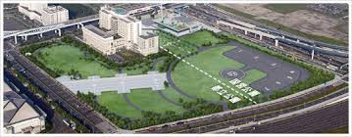

*Figure 1. Tokyo Rinkai Disaster Prevention Park 1*

In Metropolitan Tokyo, parks have become designated locations and central bases of operations for disaster prevention. The Tokyo Rinkai Disaster Prevention Park is one of the many designated bases of operations that houses emergency response facilities.4 During standard hours of operation, the park promotes disaster preparedness programs (simulations, training, knowledge-sharing) that attracts a variety of interests from organizations, the general public, and tourists.5 Additionally, the park connects with the adjacent municipal parks to create a 132000 m2 urban landscape that brings people to the waterfront.6

*BC Flood Emergency Plan (BC, Canada):*

The British Columbia Flood Emergency Plan outlines the framework for the province to coordinate flood-related activities.7 The roles and responsibilities of provincial ministries, first nations, and local authorities are clarified within the emergency plan. The plan also outlines the concept of operations that fosters collaboration between these groups.8 The Flood Emergency Plan defines emergency management as a ‘continuous process’ consisting of four phases: mitigation, preparedness, response, and recovery.9 Within these phases are general actions that are undertaken by first nation groups, ministries, and local authorities.

*References:*

1. The Arlington Group Planning Architecture Inc., et al. *Sea Level Rise Adaptation Primer*. pp. 39. https://www2.gov.bc.ca/assets/gov/environment/climate-change/adaptation/resources/slr-primer.pdf
2. Ibid, 40.
3. Ibid, 40.
4. *The Tokyo Rinkai Disaster Prevention Park*, http://www.ktr.mlit.go.jp/showa/tokyorinkai/english/index.htm.
5. Ibid.
6. Ibid.
7. *Provincial Flood Emergency Plan*. 31 May 2019, pp. 5. https://www2.gov.bc.ca/assets/gov/public-safety-and-emergency-services/emergency-preparedness-response-recovery/provincial-emergency-planning/provincial-flood-emergency-plan.pdf.
8. Ibid, 5.
9. Ibid, 12.
10. Policy Safety Canada (2019). Emergency Management Planning. <https://www.publicsafety.gc.ca/cnt/mrgnc-mngmnt/mrgnc-prprdnss/mrgnc-mngmnt-plnnng-en.aspx>.
11. Selwyn District Council. (2006). Tsunami Response Plan. <https://docs.google.com/document/d/1C2F1qnnybjJl3F4FTZVDjUQ_CnlzER61/edit#>
12. Martinsen, R. (2015). 5 Key Benefits to Emergency Planning and Response Technology. Hexagon. SAFETY & INFRASTRUCTURE DIVISION. <https://blog.hexagonsafetyinfrastructure.com/5-key-benefits-to-emergency-planning-and-response-technology/>
13. Johnson, P. K., Stennis, N. K. and Goddard-Greenbelt, J. H. (2013). Challenges and Lessons Learned NASA Johnson Space Center and the Houston/Galveston Area Emergency Planning: Challenges & Lessons Learned. <https://www.hq.nasa.gov/office/codej/codejx/ClimateChangeWorkshops/PDF_TAGGED/9a_JSC_Emergency_Response_JSC_5-7-13_Kolkmeier_TAGGED1.pdf>
14. Ontario Mass Evacuation Plan Annex: (2013). Guideline for the Development of a Municipal Evacuation Planhttps://docs.google.com/document/d/1C2F1qnnybjJl3F4FTZVDjUQ_CnlzER61/edit?pli=1

*Images:*

1. *Figure 1. Ministry of Land, Infrastructure, Transport and Tourism, Kanto Regional Development Bureau (2011).* *Tokyo Rinkai Disaster Prevention Park.* https://www.gotokyo.org/en/spot/484/images/484_0341_1_1400x1100.jpg.

**Accommodate**

**Evacuation Routes**

*Overview:*

Evacuation routes are accessways that are constructed above flood levels and that connect flood risk areas to mainland areas that are safely above flood plains. Evacuation routes can be integrated with a transportation network by constructing a new elevated road or by designating a lane on an existing road as an evacuation route. Evacuation routes are included in the flood protection management plans of communities that are vulnerable to flooding. Evacuation routes are equipped with the appropriate signage that conveys the importance of flood control and the potential for flooding within a community. Ultimately, the effectiveness of evacuation routes is dependent on the allocation of resources towards maintaining an efficient road network and the type of evacuation that is triggered by a flood event.

*Types of evacuations:*

* **Pre-emptive evacuations** are undertaken where it is obvious that a delay may impede evacuation efforts.
* **No-notice evacuations** are undertaken where a threat is affecting a community, where decisions must be taken with limited information, and when waiting for additional information may increase the impact of a disaster event on a community.
* **Partial evacuations** are contained within localized areas within a municipality.
* **Widespread evacuations** are undertaken where a disaster, e.g., a flood event affects an entire district, city, or region. Widespread evacuations involve the movement of large amounts of evacuees. Large-scale evacuations are more likely to place a higher demand on transportation networks and therefore as a short-term measure, some evacuees may be required to shelter in place. 8

*Benefits*

* Allow coastal communities to quickly move out of harm's way before or when a disaster event occurs
* Can be integrated into a wider resilient road network
* Roadways that are elevated above flood plains could serve as temporary evacuation centers 9
* Provides easy access to emergency shelters before and during a disaster event 9

*Challenges*

* Can be expensive depending on the scale of the infrastructure required
* Evacuation rates may exceed the capacity of the evacuation route
* Effective use during a disaster requires coordination with the wider road network system
* Extreme events may lead to the excessive build-up of traffic that could create adverse effects on the transportation network. 10, 11

*Windsor Flood Evacuation Route (Windsor SYD, Australia):*

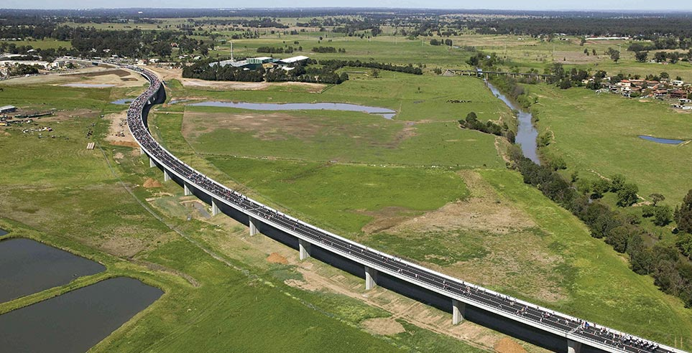

*Figure 1. Windsor Flood Evacuation Route 1*

In 2003, the development of a new flood evacuation route was proposed by the Roads and Traffic Authority of Syndey northwest.1 The proposed design included a 2.6 km elevated roadway that is 12 meters above the floodplain that stretches across the South Creek.2 The project was designed to address the challenges related to environmental sensitivities, soil type, and erosion.3 The evacuation route was officially opened in 2007 and now provides egress during flood events and relief for traffic congestion on Windsor Road.4

*City of Richmond Evacuation Plan (Richmond BC, Canada):*

The City of Richmond provides an evacuation plan that outlines the basic protocols and responsibilities and the coordination of resources that are required for evacuation.5 The evacuation plan covers the organization of transportation and the availability of evacuation routes, in the event of an emergency. In the event of an emergency, evacuation routes are activated by the City’s EOC or Site Incident Commander, to quickly move the public to areas of safety.6 Existing evacuation routes provide access from Richmond into Vancouver, New Westminster, Surrey, North Delta, Delta, Mitchell Island, and Lulu Island.7

*References:*

1. “Windsor Flood Evacuation Route.” *Aurecon*, https://www.aurecongroup.com/projects/transport/windsor-flood-evacuation-route.
2. Ibid.
3. Ibid.
4. Ibid.
5. City of Richmond. *Richmond Evacuation Plan*. 12 Dec. 2008, pp. 42. https://www.richmond.ca/__shared/assets/evacuation_plan23714.pdf.
6. Ibid, 42.
7. Ibid, 42-43.
8. Ontario Mass Evacuation Plan Annex: (2013). Guideline for the Development of a Municipal Evacuation Planhttps://docs.google.com/document/d/1C2F1qnnybjJl3F4FTZVDjUQ_CnlzER61/edit?pli=1
9. Green Roads for Water. (n.d). https://roadsforwater.org/guideline/coastal-lowlands/roads-as-temporary-flood-shelters-and-evacuation-routes/
10. Tamima, U., & Chouinard, L. (2012). Framework for earthquake evacuation planning: case study for Montreal, Canada. Leadership and Management in Engineering, 12(4), 222-230.
11. Helderop, E., & Grubesic, T. H. (2019). Flood evacuation and rescue: The identification of critical road segments using whole-landscape features. *Transportation research interdisciplinary perspectives*, *3*, 100022. https://www.sciencedirect.com/science/article/pii/S2590198219300223

*Images:*

1. Figure 1. Aurecon. (n.d). Windsor Flood Evacuation Route, Australia. https://www.aurecongroup.com/projects/transport/windsor-flood-evacuation-route

**Accommodate**

**Scour Protection**

*Overview:*

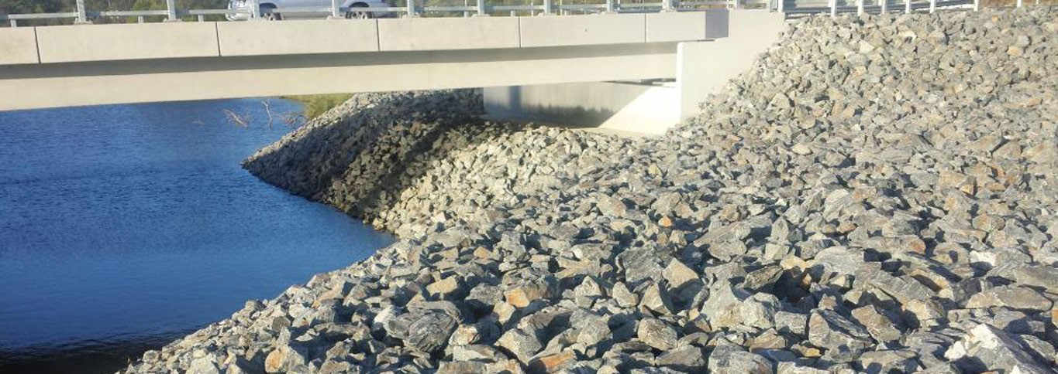

*Figure 1. Bridge scour protection 1*

Scours are property-specific structural tools that are used to protect shoreline structures or building foundations from exposure to the corrosive effects of moving water. Scour protection is typically constructed from riprap or other types of material. The material is applied around the foundation of a structure to prevent erosion from wave action.1 Scours are commonly used in protecting the bases of bridge foundations, seawalls, coastlines near highways, rails, or pipelines.2 The strategy has limited protection as it only minimizes risk directly to the foundation of buildings and structures.3

*Types of scour protection measures:*

* A **spur dike** is an elongated structure with one end on a bank of a stream and the other end projecting into the water. Spur dikes have been used widely for the protection of stream banks against erosion. They have also been used for the enhancement of aquatic habitats by creating stable pools in disturbed unstable streams. 10
* A **debris basin** consists of an earth dam and a barrier constructed across a drainage way or other suitable location to collect sediment. Excess runoff from the dam occurs through spillways. Small pools of water flow through a sediment basin which captures and discharges runoff from adjacent lands. This allows larger silt particles to drop out into the pool. 11
* **Check dams** also referred to as ditch checks, dikes, and wattles, may be temporary or permanent linear structures that are installed in a perpendicular position to the flows emanating from drainage ditches, channels, and swales. Check dams help to reduce flow velocity and prevent the down-cutting of channels 12
* **Longitudinal stone toe** is an alternative form of a windrow revetment where stones are placed along the existing streambed rather than on top of a bank. “The longitudinal stone toe is laced with a crown well below the top bank, either against the eroding bank line or a distance riverward of the high bank.” 13

*Benefits:*

* Longitudinal stones help to preserve significant amounts of the existing vegetation on a bank slope. It also encourages the growth of additional vegetation when the bank slope is stabilized. 14
* The cost of protecting local scours is low. The maintenance requirements are also low. Additionally, local scours are relatively easy to construct and adjust to minor scouring. 15
* Check dams help to promote infiltration which results in a reduction in channel erosion. Check dams also serve as traps for coarse sediments. 17
* Check dams can reduce peak stormwater runoff.
* Scour protection with lower levels of invert can improve discharge and reduce flooding levels.

*Challenges*

* Longitudinal stone toe protection only provides toe protection. It does not directly protect the mid and upper banks. Some erosion of the mid and upper bank areas may occur during long-duration, high energy flows, particularly, before these areas stabilize and become vegetated. 14
* Local scours may be destabilized by a moderate flood before vegetation is re-established. 15
* Spur dikes can lead to the contraction of the flow path which subsequently increases flow velocity in the contracted section. 16
* Check dams can lead to a reduction in channel conveyance capacity thereby increasing the probability of overtopping. 17

*Gulf of Mexico Wave Protection (Franklin County FL, USA):*

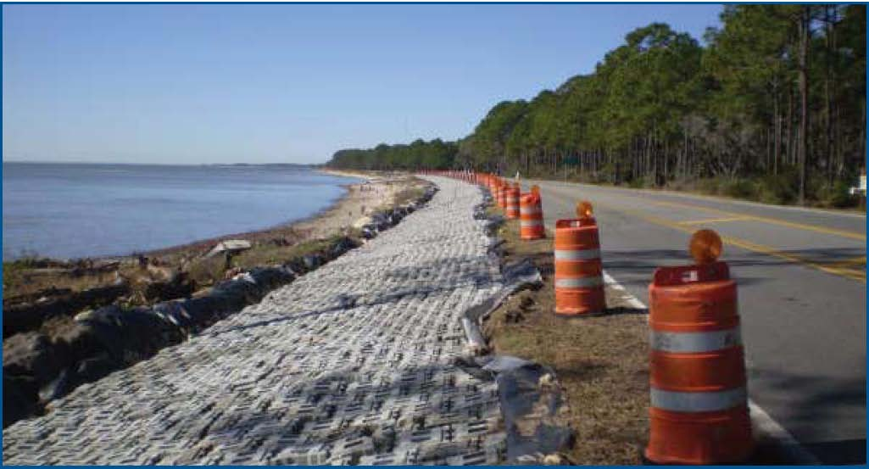

*Figure 2. Shoreline protection utilizing interlocking blocks 2*

Along State Route 30/US 98 Coastline, beach erosion has been a major problem for more than 30 years.4 The highway is adjacent to the coastline and coastal erosion continues to destabilize the roadway. In response, the County decided to construct a revetment system along the coastline using a Contech ArmorFlex revetment system.5 The ArmorFlex revetment system features interlocking blocks with a high unit weight that can withstand wave action and a porous system that promotes vegetation and habitat enhancement.6

*Shubenacadie River (Shubenacadie NS, Canada):*

During the 1980s and 1990s, the Nova Scotia Department of Agriculture and the Nova Scotia Department of Environment implemented several stream bank protection projects along the Shubenacadie River to mitigate the impacts of erosion on water quality and marine habitat.7 Gabion baskets and mats were used in the stabilization of the river bank to protect the adjacent road.8 Other transportation infrastructures such as the Cheticamp Bridge that spans across the Shubenacadie River are also protected using similar gabion mats to protect the foundations of the bridge from erosion.9

*References:*

1. The Arlington Group Planning Architecture Inc., et al. *Sea Level Rise Adaptation Primer*. pp. 61. https://www2.gov.bc.ca/assets/gov/environment/climate-change/adaptation/resources/slr-primer.pdf
2. Ibid, 61.
3. Ibid, 62.
4. “Gulf of Mexico Wave Protection.” *Contech Engineered Solutions*, https://www.conteches.com/knowledge-center/case-studies/details/slug/gulf-of-mexico-wave-protection.
5. Ibid.
6. Ibid.
7. Brenton, Paul, and John McCabe. *Stream Bank Protection Project*. Nov. 2013, pp. 2. http://www.nsfa-fane.ca/efp/wp-content/uploads/2018/08/stream-bank-protection-final-report.pdf.
8. Ibid, 4.
9. Leys, Vincent, and Daniel Bryce. *Adapting to Climate Change in Coastal Communities of the Atlantic Provinces, Canada: Land Use Planning and Engineering and Natural Approaches*. Mar. 2016, pp. 27. <https://research.fit.edu/media/site-specific/researchfitedu/coast-climate-adaptation-library/canada-amp-arctic/canada---atlantic/Leys--Bryce.--2016.--CC-in-Coastal-Communities-of-the-Atlantic-Provinces,-Land-Use,-Engineering-Natural-Approaches.pdf>.
10. Kuhnle, R. (2020). USDA. Watershed Physical Processes Research: Oxford, MS. https://www.ars.usda.gov/southeast-area/oxford-ms/national-sedimentation-laboratory/watershed-physical-processes-research/docs/local-scour-in-the-vicinity-of-spur-dikes/#:~:text=A%20spur%20dike%20can%20be,pools%20in%20unstable%2C%20disturbed%20streams.
11. Steichen, J. (2020). Design Criteria for Debris Basins. https://extension.missouri.edu/publications/g1528
12. Minnesota Pollution Control Agency. (2019). Sediment control practices - Check dams (ditch checks, ditch dikes). [https://stormwater.pca.state.mn.us/index.php/Sediment_control_practices_-_Check_dams_(ditchttps://www.nrcs.usda.gov/wps/PA_NRCSConsumption/download?cid=nrcseprd526807&ext=pdfh_checks,_ditch_dikes)](https://stormwater.pca.state.mn.us/index.php/Sediment_control_practices_-_Check_dams_(ditch_checks,_ditch_dikes))
13. Biedenharn, D. S., Elliott, C. M. and Watson, C. C. (1997). THE WES STREAM INVESTIGATION AND STREAMBANK STABILIZATION HANDBOOK. <https://www.nrcs.usda.gov/wps/PA_NRCSConsumption/download?cid=nrcseprd526807&ext=pdf>
14. Canilho, H., & Fael, C. (2018). Velocity Field Analysis of a Channel Narrowed by Spur-dikes to Maximize Power Output of In-stream Turbines. Journal of Sustainable Development of Energy, Water and Environment Systems, 6(3), 534-546. <https://agupubs.onlinelibrary.wiley.com/doi/full/10.1029/2007WR006489>
15. Burcharth, H. F., Zanuttigh, B., Andersen, T. L., Lara, J. L., Steendam, G. J., Ruol, P., ... & Nørgaard, J. Q. H. (2015). Innovative engineering solutions and best practices to mitigate coastal risk. In Coastal risk management in a changing climate (pp. 55-170). Butterworth-Heinemann. <https://www.sciencedirect.com/topics/engineering/local-scour>
16. Giglou, A. N., Mccorquodale, J. A., & Solari, L. (2018). Numerical study on the effect of the spur dikes on sedimentation pattern. Ain Shams Engineering Journal, 9(4), 2057-2066.
17. TRPA BMP Handbook (2014). Check dams. https://www.tahoebmp.org/Documents/BMPHandbook/Chapter%204/4.3/k_ChckDam.pdf

*Images:*

1. *Figure 1. Envirostruct Services. (2020). Scour Protection.* [*http://estruct.com.au/waterways/revetment-walls/scour-protection/*](http://estruct.com.au/waterways/revetment-walls/scour-protection/)
2. *Figure 2.* “Gulf of Mexico Wave Protection.” *Contech Engineered Solutions*, https://www.conteches.com/knowledge-center/case-studies/details/slug/gulf-of-mexico-wave-protection.

**Accommodate**

**Secondary Dikes**

*Overview:*

Secondary dikes work in conjunction with primary dikes to reduce the impact of a flood if the primary dike is breached.1 Several secondary dikes designs may be similar to that of a primary dike but on a smaller scale. For example, in the city of Winnipeg, and secondary dike is simply defined as ***(any permanent dyke or other flood control work within the City of Winnipeg which has been, or is, constructed between a primary dyke and the channel).*** Hence, secondary dikes are classified based on their position and the role they play in flood mitigation. In the Netherlands, secondary dikes were historically known as ‘sleeper dikes’: a backup dike which is located between the main dike and the land.2 Today, secondary dikes are still a viable adaptation strategy and are usually placed behind the main dike to protect high-value residential land in the case of a breach. In between the main dike and secondary dike are the least sensitive assets such as parks and open spaces that can withstand flooding.

*Types of secondary dikes:*

* A **berm** is a ridge that is constructed from compacted soil. The dike could be made from composted material, gravel, crushed rock, sandbags, gravel bag barriers, or straw bales
* A **temporary dike** is designed to intercept and prevent runoff from entering a disturbed area It diverts or directs the water to a controlled or stabilized drainage outlet. 7

*Benefits:*

* Serves to intercept flood runoff and sediment from exposed disturbed areas, such as a newly-constructed road or slope, and filter sediment.
* Redirects the flood water to a slope drain, sediment basin, or other specified location.
* Intercepts runoff from undisturbed upland areas, and redirects runoff to a sediment

basin or specified location. 7

* Limits flooding to areas that are less developed which helps to protect more developed areas.

*Challenges*

* Must be designed and constructed to mitigate erosion caused by water diversion and concentrated runoff flow.
* For construction, topographical features such as space, degree of slope, and access can be limiting or prohibitive factors 7

*Hondsbossche Zeewering Sleeper Dike (Holland, The Netherlands):*

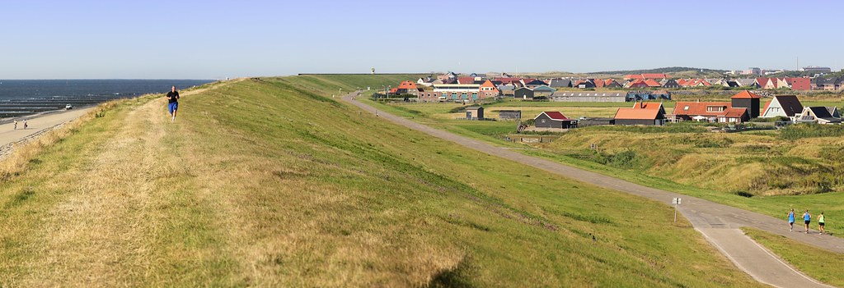

Figure 1. *Sleeper Dike near the Hondsbossche Zeewering* 1

In 1526, a secondary dike was constructed behind the Hondsbossche Zeewering Dike because of concerns related to the weakness of the sea wall.3 In 1570, the main dike was breached, and the secondary dike prevented North Holland from being flooded. Secondary dikes or sleeper dikes were commonly used all over the Netherlands as part of the Delta Plan (Dutch dike system).4 However, most of these dikes no longer have a function in flood protection after the improvement of the Delta Plan but remain protected today for their cultural and historical value.5

*Terra Nova Secondary Dike (Richmond BC, Canada):*

As part of the Richmond Dike Master Plan, the City of Richmond British Columbia is considering an alternative dike alignment in the Terra Nova area. As an alternative, the Dike Master Plan identifies the alignment to be set inland as part of a secondary dike. The dike is intended to protect sensitive assets such as private homes and heritage sites while less sensitive assets such as parks, trails, and open spaces can be flooded, in the case of a breach.6

*References:*

1. The Arlington Group Planning Architecture Inc., et al. *Sea Level Rise Adaptation Primer*. pp. 106. https://www2.gov.bc.ca/assets/gov/environment/climate-change/adaptation/resources/slr-primer.pdf
2. “Sleeper Dike.” *Wikipedia*, Wikimedia Foundation, 20 June 2019, https://en.wikipedia.org/wiki/Sleeper_dike.
3. “Dutch Dikes.” *Dike Map of the Netherlands*, http://dutchdikes.net/map/.
4. Ibid.
5. “Sleeper Dike.” *Wikipedia*, Wikimedia Foundation, 20 June 2019, https://en.wikipedia.org/wiki/Sleeper_dike.
6. *City of Richmond Dike Master Plan*. 6 Dec. 2016, <https://www.richmond.ca/__shared/assets/_3_DikeMasterPlan_Phase246195.pdf>.
7. Anonymous (nd). Best Management Practices Manual. Chapter 2 Temporary Sediment Control Management. DIKES AND BERMS. https://apps.itd.idaho.gov/Apps/env/BMP/PDF%20Files%20for%20BMP/Chapter%202/SC-1%20Dikes%20and%20Berms.pdf

*Images:*

1. *A Typical Sleeper Dike near the Hondsbossche Zeewering*. https://upload.wikimedia.org/wikipedia/commons/3/3b/SlaperdijkHondsbossche.jpg.

**Accommodate**

**Warning System**

*Overview:*

Early warning systems form an important element of disaster risk management. Compared to systems for flood forecasting, that assess risk, early warning systems sends out a warning either when a community is at risk from imminent flooding or when a flood event is already affecting a community. There are four key elements of an early warning system for floods; these include a) assessments of flood risks, b) monitoring of local hazards (forecasts) and warning service, c) dissemination of flood risk information, and d) building community response capabilities. 12 Warning systems can be incorporated into most existing communication infrastructures. This strategy is particularly valuable where protection through large scale, hard defenses, is not acquirable.1 Warning systems require constant monitoring and risk assessment.2 They are generally low-cost and have proven to be successful in numerous developed or developing countries.3

*Types of early warning systems:*

* **Sensor Networks for Flood Detection** are used for flood detection in areas that are affected by heavy rainfall and hurricanes.
* In a **Based and GIS-Based Flood, Warning data** is collected in real-time from hydrological observation stations. The data is then processed by a centralized computer system and results are sent to a client computer in a control room via remote access.)
* **Flood Warning based on Radio, SMS, TVs, and Phones use** a microcontroller from the “ARM family, a Marvell 88F6281 and the Unix FreeBSD interface and integrated database.” Hydrological data is then sent in real-time for decision making via radio communication. 11

*Benefits:*

* Provides a prediction of the scale, timing, location, and likely damage that might be caused by an impending flood
* Provides timely notice for the release of gated dam water. This helps to, reduce damage to communities and ecosystems
* Can serve as an adaptation measure at the individual and household level because data can be sent directly to individuals within a household.
* When implemented at the local and regional scales, it can reach those groups that are especially vulnerable to flooding. 12
* Helps to improve disaster preparedness and hence can significantly reduce expensive disaster relief efforts.

*Challenges*

* *Success is dependent on public acceptance and participation*
* Can sometimes be easily ignored especially warning systems along highways
* Flood warning efficiency and distribution could be reduced by limited access to communication networks, particularly in remote regions
* False alarms could lead to uncertainty and hesitancy in future responses.
* Availability and accessibility of good quality real-time data may be limited 12

*Cyclone Warning System (Bangladesh):*

Historically, Bangladesh has been an active area for tropical cyclones. Unfortunately, a lack of protective measures has resulted in high death and casualty rates.4 As an adaptation response, Bangladesh implemented the Cyclone Preparedness Programme (CPP) which focuses on infrastructure development, an early warning system, and cyclone shelters.5 The warning system consists of three components: monitoring, evaluation, and response and draws data from multiple sources.6 The warning system has proven to be successful during the 1970,1991 and 2007 cyclones which resulted in fewer deaths.7

*River Forecast Centre (BC, Canada):*

The River Forecast Centre is a live interactive platform used by the province of British Columbia to provide information on seasonal water supply and flood risk, and river and streams flow predictions within the region.8 The interactive platform allows emergency managers and the public to prepare and/or respond to bulletins, maps, and flood warnings.9 Flood warnings and advisory maps identify current and future conditions in major basins and sub-basins at different advisory and warning levels. The center also provides high streamflow advisories, flood watch, and flood warnings.10

*References:*

1. Zhu, Xianli, et al. *Technologies for Climate Change Adaptation - Coastal Erosion and Flooding*. 2010, pp. 92. https://orbit.dtu.dk/files/5699563/Technologies for Climate Change Adaptation-Coastal Erosion and Flooding.pdf.
2. Ibid, 92.
3. Ibid, 95-96.
4. Ibid, 99.
5. Ibid, 99.
6. Ibid, 99.
7. Ibid, 100.
8. Ministry of Forests Lands and Natural Resource Operations. “River Forecast Centre.” *Province of British Columbia*, Province of British Columbia, 14 May 2019, https://www2.gov.bc.ca/gov/content/environment/air-land-water/water/drought-flooding-dikes-dams/river-forecast-centre.
9. Ibid.
10. Ibid.
11. Keoduangsine, S., Goodwin, R., & Gardner-Stephen, P. (2014). A Review of Flood Warning Systems in Developed and Developing Countries. International Journal of Future Computer and Communication, 3(3), 172.
12. United Nations, DHI Centre of Water and Environment. (n.d). Early warning systems for floods. https://www.ctc-n.org/sites/www.ctc-n.org/files/resources/early_warning_systems_for_floods_0.pdf

**Accommodate**

*Overview:*

**Wet Floodproofing**

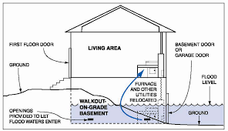

Figure 1. Wet floodproofing for a walkout basement 1

Wet floodproofing is the measure of allowing water to enter and exit a structure with minimal or no damage. Wet floodproofing includes a suite of measures including the use of flood-resistant materials, below the Base Flood Elevation (BFE), elevation of electrical and mechanical services, openings that allow drainage from the inside of the building to the outside, and breakaway walls. The applicability of wet floodproofing is limited, however, in small residential properties, it can be a viable alternative compared to elevation.1 The strategic placement of openings allows for the equalization of hydrostatic pressure so that water can flow in and out.2

*Types of wet floodproofing:*

* **Flood vents** allow water into a building to enable the equalization of the interior and exterior hydrostatic pressures. This significantly reduces the likelihood of wall failures and structural damage.
* **Protection of service equipment** involves moving utilities and appliances to areas in a building that are higher than the level of flood protection. Equipment and appliances may be moved to areas such as attics or utility rooms.
* **Anchoring** involves securing foundations, fuel tanks, equipment, and other components that are located below the level of flood protection. This helps to prevent flotation, collapse, and lateral movement of equipment during a flood.
* **Flood resistant materials** refer to replacing building materials in flood-prone parts of a structure with materials that are resistant to flood damage. For example, carpet and paneling, and gypsum wallboard can be replaced with materials that require cleaning rather than replacing. 9

*Benefits:*

* Leads to a reduction in clean-up time and cost.
* Often less costly than other flood mitigation or adaptation measures.
* Installation of flood vents, allow for the equalization of internal and external hydrostatic pressures thereby decreasing loads on the walls and floors of a building. 10
* Except for basement contents, relocating or storing costs after a flood warning are normally covered by flood insurance. 9

*Challenges*

* A building may be uninhabitable during a flood event, hence, alternative accommodation must be sought
* If the inside of a structure becomes contaminated by sewage and other substances in floodwater, extensive cleanup may be necessary
* Does not reduce possible damage from high-velocity floodwater flow or wave action
* May not result in a reduction in premiums for flood insurance 9

*The National Flood Insurance Programme (USA):*

The National Flood Insurance Programme (NFIP) guarantees flood insurance to communities that regulate and ensure that floodplain development meets certain criteria.3 One of the criterion that the NFIP requires is that all new non-residential developments are flood-proofed.4 The design of a building that is below flood elevation must have watertight walls, structural components that can resist hydrostatic and hydrodynamic loads, and utilities that are protected from flood damage.5 Also, NFIP requires that flood-resistant materials must be used in parts of the build that are exposed to floodwater.6

*Spray-and-wash Basement (Calgary AB, Canada):*

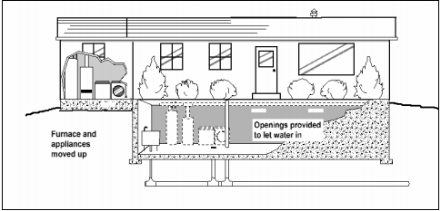

Figure 2. Example of a basement with wet floodproofing 1

In Calgary, homeowners renovate their basements with flood-resistant materials. The renovation required the existing basement to be gutted and replaced with materials such as steel stairs, polished concrete floors, and walls that are impervious to water.7 The renovation materials cost about 30 percent more than the conventional building materials.8 The use of water-resistant material allows for post-flood cleanup to be much faster and less costly.

*References:*

1. The Arlington Group Planning Architecture Inc., et al. *Sea Level Rise Adaptation Primer*. pp. 71. https://www2.gov.bc.ca/assets/gov/environment/climate-change/adaptation/resources/slr-primer.pdf
2. FEMA. *Homeowner's Guide to Retrofitting*. https://www.fema.gov/pdf/rebuild/mat/sec6.pdf.
3. Zhu, Xianli, et al. *Technologies for Climate Change Adaptation - Coastal Erosion and Flooding*. 2010, pp. 75. https://orbit.dtu.dk/files/5699563/Technologies for Climate Change Adaptation-Coastal Erosion and Flooding.pdf.
4. Ibid, 75.
5. Ibid, 75.
6. Ibid, 75.
7. “Flood-Wary Homeowner Installs 'Spray-and-Wash' Basement’.” *CBCnews*, CBC/Radio Canada, 20 Mar. 2014, https://www.cbc.ca/news/canada/calgary/flood-wary-homeowner-installs-spray-and-wash-basement-1.2579866.
8. Ibid.
9. Southern Tier Central Regional Planning and Development Board (2019). Wet Floodproofing. <http://www.stcplanning.org/usr/Program_Areas/Flood_Mitigation/Floodproofing/FProof_05_Wet_Floodproof.pdf>
10. Anonymous. (n.d.). CHAPTER 6 – WET FLOODPROOFING. https://www.fema.gov/media-library-data/20130726-1608-20490-7205/fema551_ch_06.pdf

*Images:*

1. *Figure 1 and 2. Anonymous. (n.d.). CHAPTER 6 – WET FLOODPROOFING.https://www.fema.gov/media-library-data/20130726-1608-20490-7205/fema551_ch_06.pdf*